**Lab 13**

1.Write a Python program and calculate the mean of the below dictionary.

test_dict = {"A" : 6, "B" : 9, "C" : 5, "D" : 7, "E" : 4}

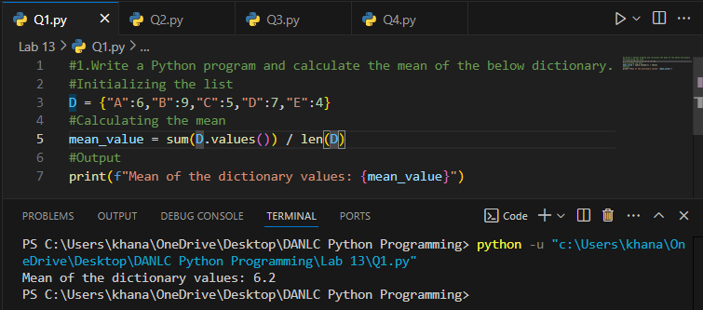

2.Write a Python script to concatenate the following dictionaries to create a new one.

Sample Dictionary : dic1={1:10, 2:20} dic2={3:30, 4:40} dic3={5:50,6:60}

Expected Result : {1: 10, 2: 20, 3: 30, 4: 40, 5: 50, 6: 60}

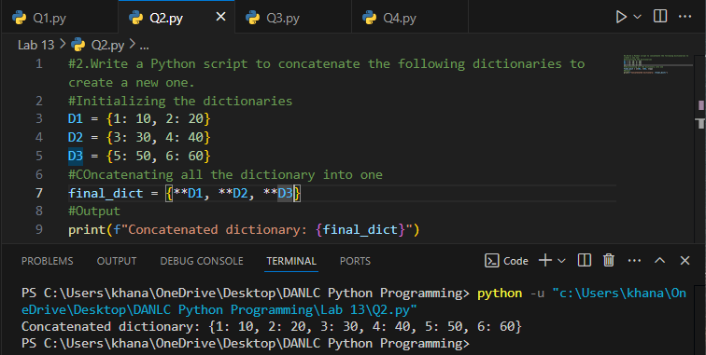

3.Write a Python program to get the key, value and item in a dictionary.

input:dict_num = {1: 10, 2: 20, 3: 30, 4: 40, 5: 50, 6: 60}

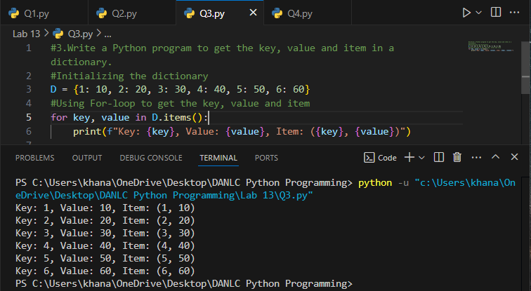

4.Write a Python program to get the key, value and item in a dictionary.

Input: input_dict = {1: 10, 2: 20, 3:None, 4: 40, 5: None, 6: 60}

